1) Create one IAM user and assign ec2,s3 full access role.

IAM 🡪 user 🡪 create user

Fill details and then click Next

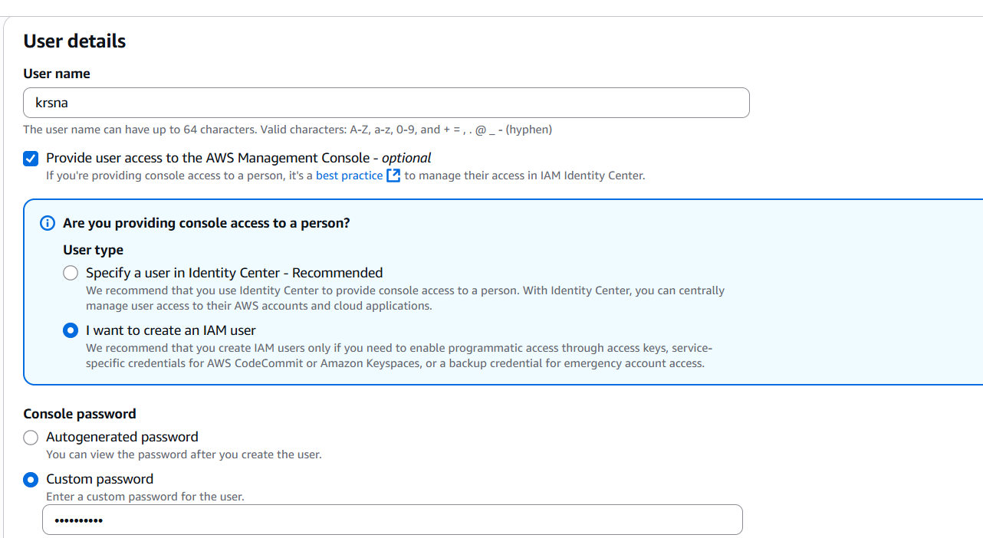

Permissions search for the

\*AmazonEC2FullAccess

\*AmazonS3FullAccess

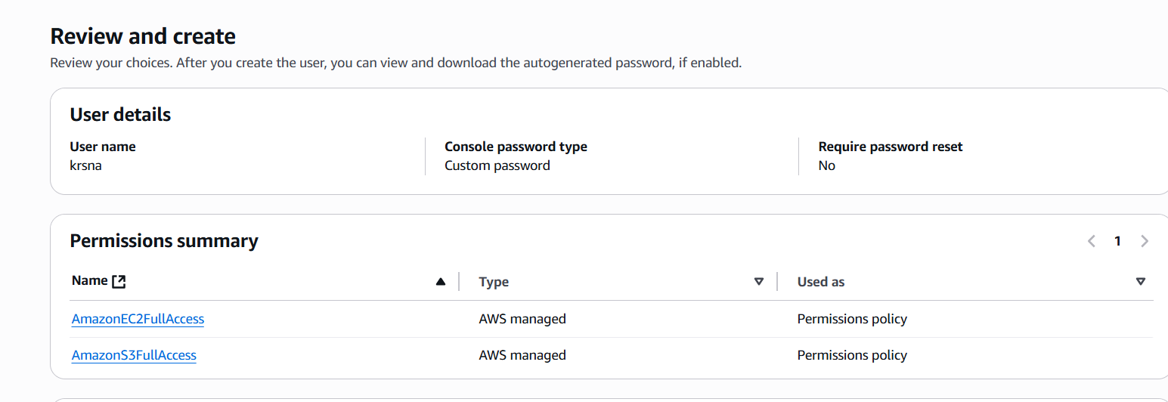

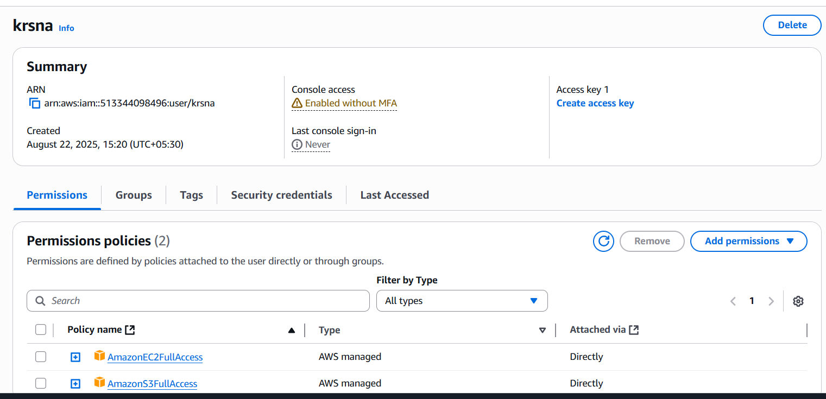

2) Create one Group in IAM and Assign Read access for ec2.

IAM 🡪 Group 🡪 Create Group and fill the details

Add AmazonEC2ReadOnlyAccess from permission policies dropdown box

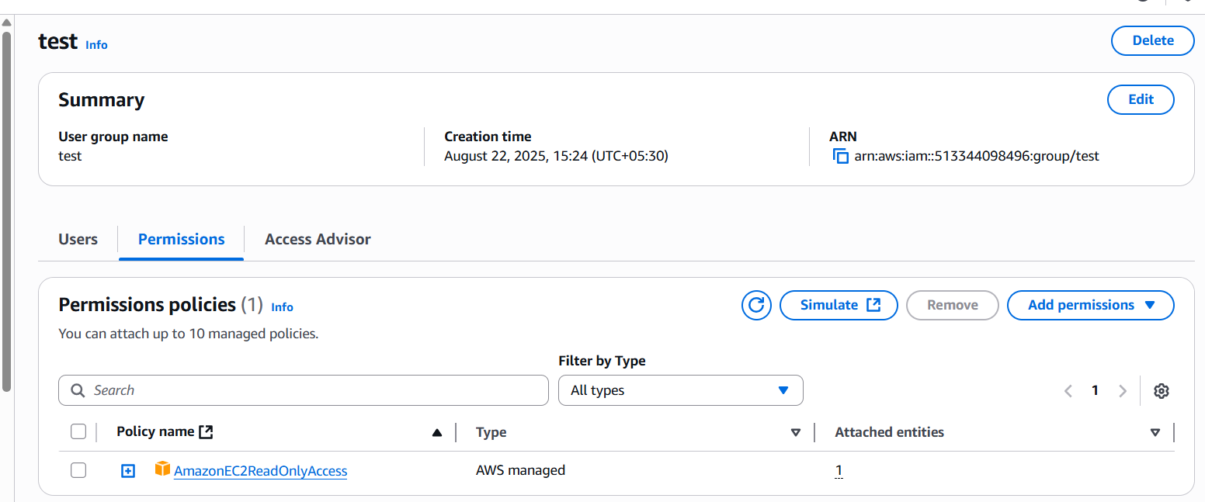

3) Create a new user with name Devops and add to the group created in task2.

IAM 🡪 User 🡪 Create User and fill the details where User name is Devops

Set permissions 🡪 Add User or Group

Select the group in which the user (devops) needed to be added

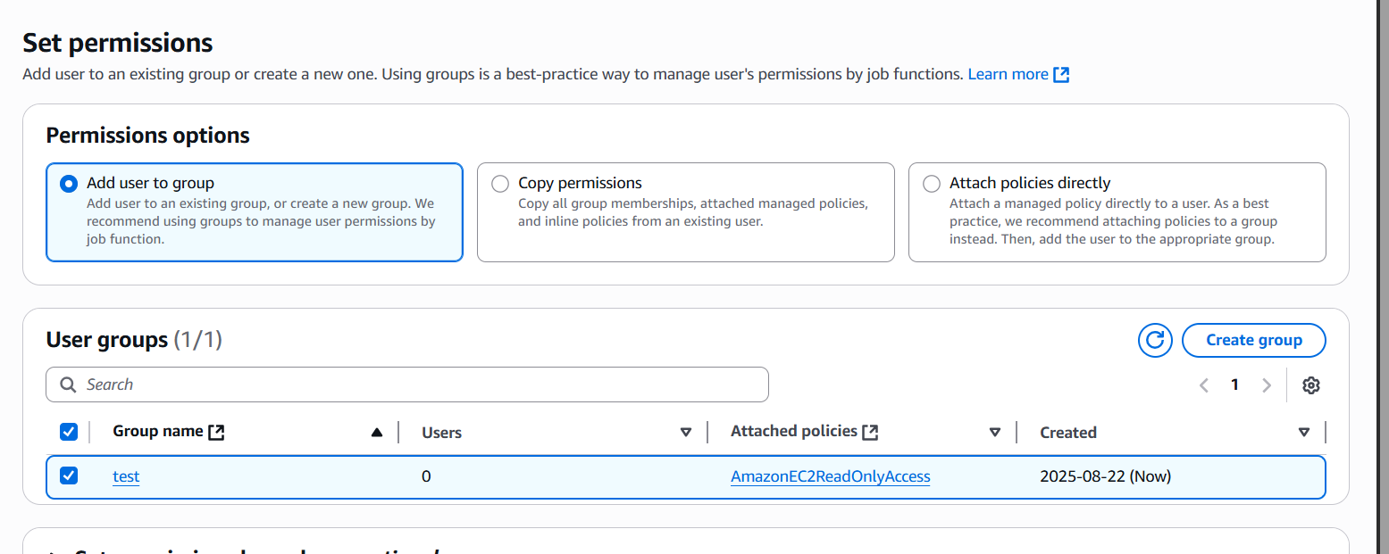

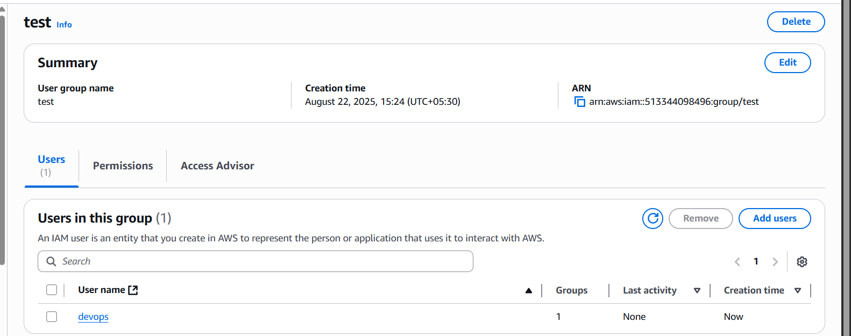

4) Write a bash script to create a IAM user with VPC full access.

Connect to EC2 instance

Create a file with the below bash script

And give permission to file with chmod 700 filename

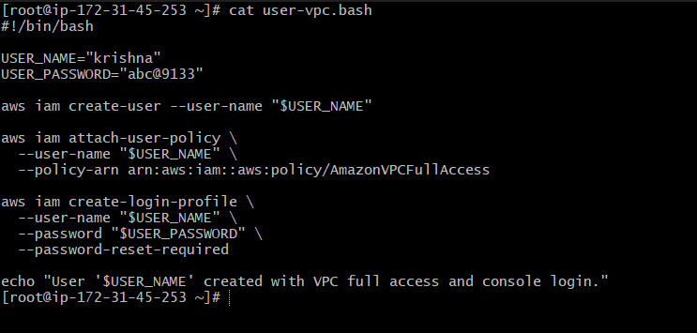

After executing the bash script user will created with AmazonVPCFullAccess

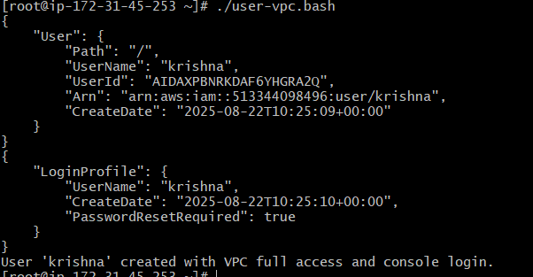

IAM 🡪 User

Check here whether the user is created with vpc full access or not

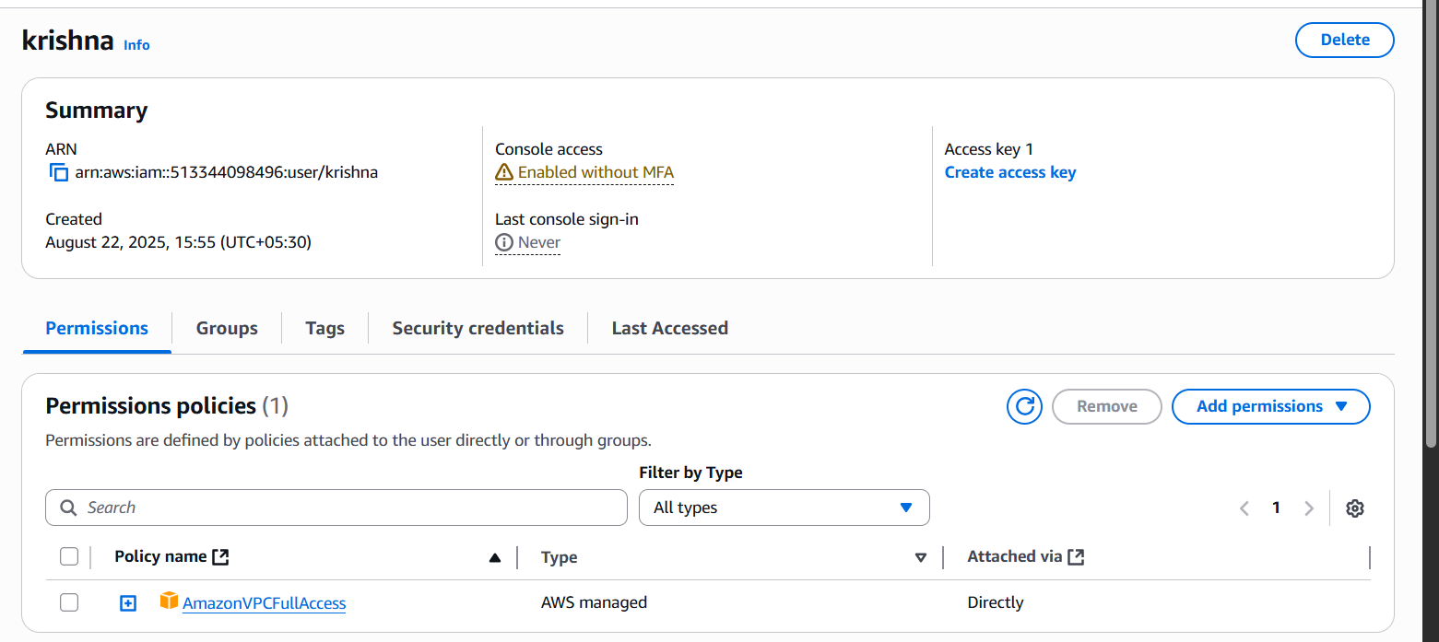

5) Create a IAM policy to access ec2 for a specific user in specific regions only.

IAM 🡪 policies 🡪 create policies

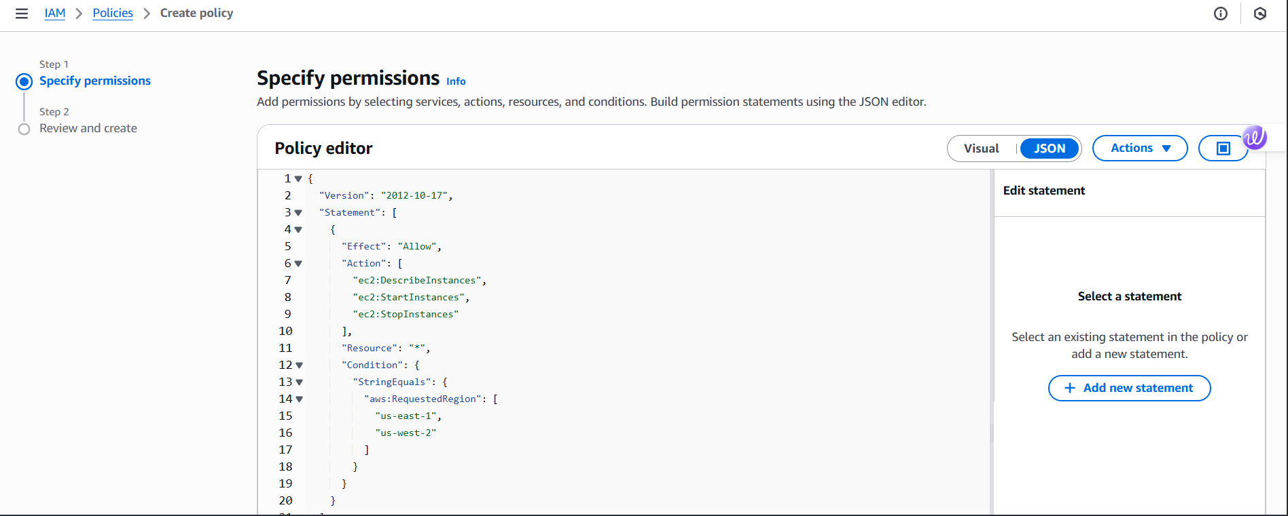

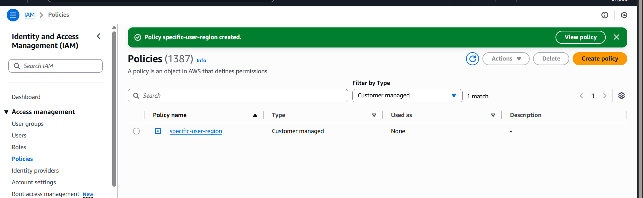

IAM 🡪 User 🡪 Permissions policies 🡪 Add Permissions

Attach the created permission policy “specific-user-region”

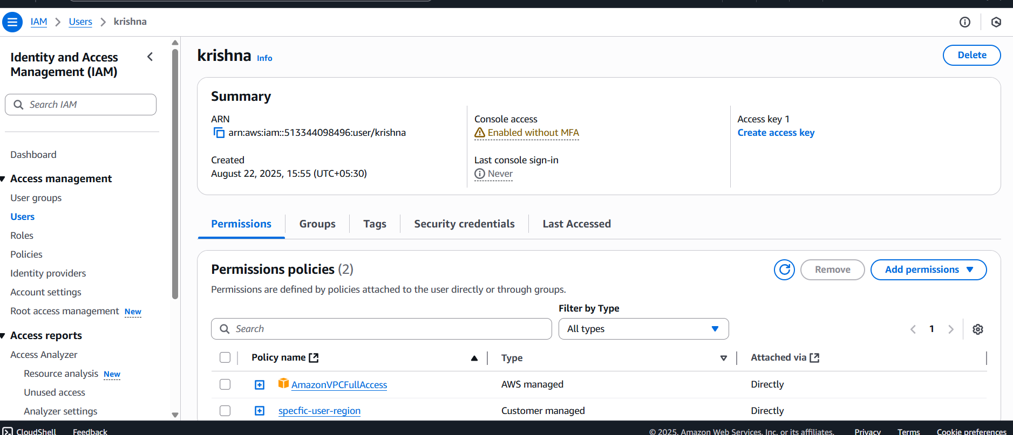

6) We have two accounts Account A and Account B, Account A user should access s3 bucket in Account B.

(Collaborate with team member and execute this.Mostly asked in every interview)

Logged in with IAM user (Krsna) and launched EC2 instance(s3-access-A-B)

